Phase 4 – RAG

Documents Created
I’ve Created Few Documents to be utilized in my RAG system for Banking Support Agent.
- Accounts – Details on various accounts which is provided by bank and its policy Documents
- Deposits – Details on Various deposits offered by Bank
- Loans – Various Loan, its eligibility, interest rates.
- Cards – Debit/Credit Cards, Various tiers and eligibility.
- Banking FAQ’s – For reference of frequently asked questions and its responses.

Vector DB used
Milvus – Zilliz cluster Created and Loaded.

Embedding used
text-embedding-3-small

Testing Responses

Bank agent response – Version 1 Testing

It retrieves All Documents loaded. I was my deposits question responded from Deposit word Document and expect Bank FAQ’s for general information for Agents but the response was not customer friendly.
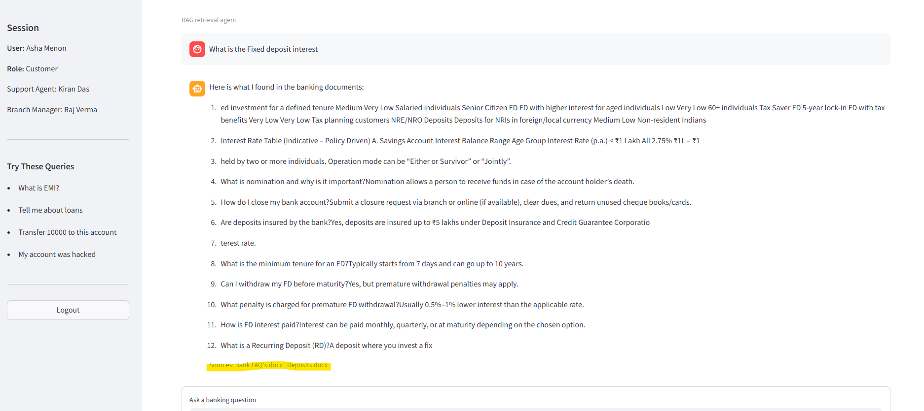
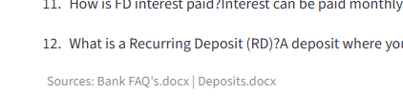
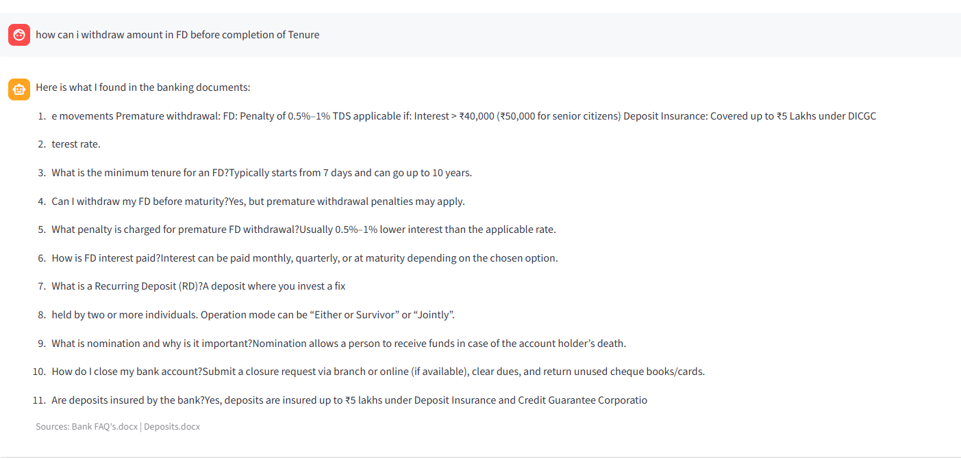
Not aware of the Context :

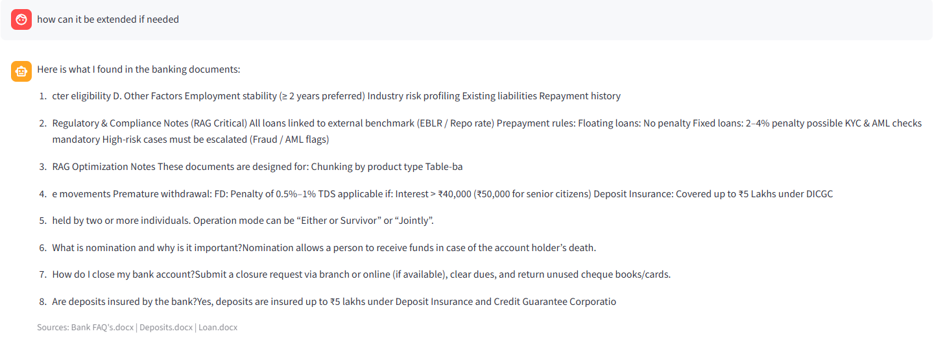

Changes made:
I improved the RAG system so it no longer returns raw chunk dumps. The new flow first routes the user query to the most relevant document type like deposits, loans, cards, or accounts, then retrieves better context from Milvus, and finally sends that context to the LLM to generate a cleaner, user-friendly answer.
I also upgraded the ingestion pipeline. Instead of flat chunks, it now uses better section-based chunking, converts the FAQ document into question-answer pairs, and stores extra metadata like document group and section title. That helps retrieval stay more relevant, while the UI still shows the source document names with each answer.

Bank agent response - Version 2 Testing:
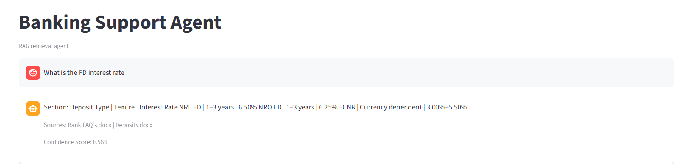

Changes Made:
I changed the answer stage so it behaves more like a real customer-facing chatbot.
What I fixed:
the RAG agent now tries the LLM more reliably
if OPENAI_BASE_URL fails, it also tries the embedding endpoint config as a fallback
if the LLM still fails, it no longer dumps raw chunk labels like Section: ...
Now the flow is: user query standalone query rewrite from chat history retrieval from Milvus retrieved chunks passed to LLM for final answersource + confidence shown in UI

If the retrieval doesn’t give any response, the fallback answer is now cleaned and phrased like:
“Based on the banking documents, here is the relevant fixed deposit information: ...”
So even fallback is more customer-facing than before.

Bank agent Response – Version 3 Testing:

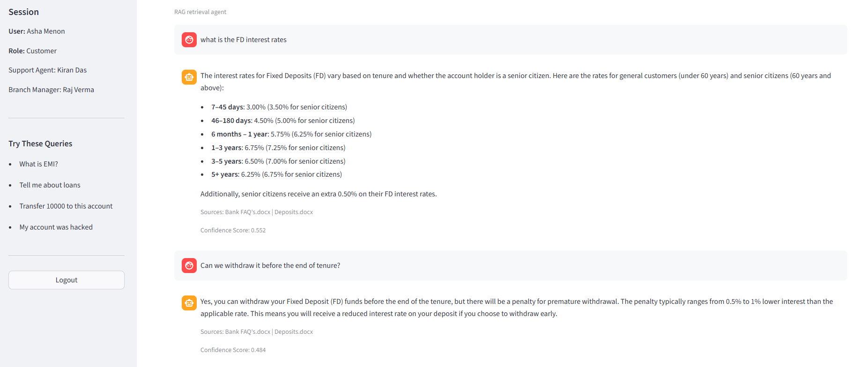The Agent gets correct interest rates and understands the Context based on history conversations.

Handle cases where relevant information is missing

Physically challenged persons FD rates are not mentioned separately but the agent responds based on information it can retrieve.

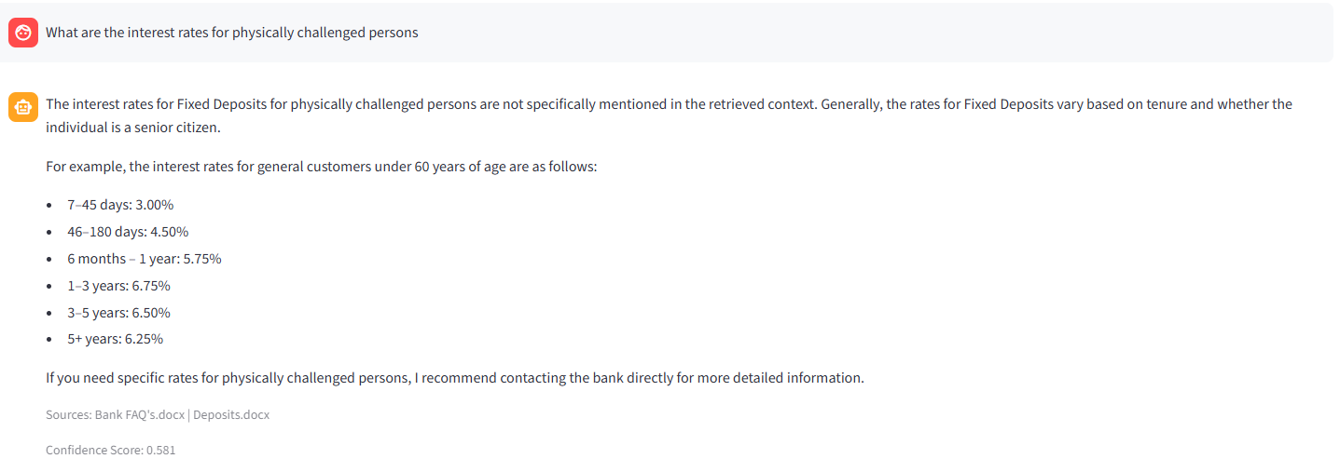
.

Connecting Retrieval Results to Agent Responses

Based on implementation:
- User query → routed to relevant document type (Deposits, Loans, Cards, Accounts, FAQ)
- Relevant chunks retrieved from Milvus
- Context passed to LLM → generates final response
- Output includes source + confidence (UI)

Key Improvement Flow
Stage | Before (V1) | After (V2 & V3)
Retrieval | All documents retrieved | Targeted document routing
Chunking | Flat chunks | Section-based + FAQ Q&A
Context Use | Weak / ignored | Strong context injection
Output | Raw chunk dumps | Clean, user-friendly answers
Fallback | Raw labels (e.g., “Section:…”) | Structured banking response
Accuracy | Low relevance | Improved accuracy (interest rates, context)
📌 Result: Retrieval is now actively shaping the response, not just being appended.

Comparison: Responses With vs Without Retrieval

Scenario 1: Fixed Deposit Interest Rates
User Query: “What is the FD interest rate?”
Mode | Sample Response
Without Retrieval (LLM Only) | “FD interest rates vary by bank and tenure. Typically ranges between 5%–7%.”
With Retrieval – V1 | “Section: Deposits → FD rates table → 6.5%, 7%, 7.25%…” (raw dump, not user-friendly)
With Retrieval – V2 | “Based on the bank’s deposit policy, fixed deposit interest rates depend on tenure. For example, 1-year FD offers around 6.5%, while longer tenures may offer higher rates.”
With Retrieval – V3 | “Based on the bank’s deposit document, FD interest rates vary by tenure. For example:  - 1 year: ~6.5%  - 3–5 years: higher rates apply  Let me know your tenure and I can guide you better.”

Scenario 2: General FAQ (Customer-Friendly Answer)
User Query: “How do I open a savings account?”
Mode | Sample Response
Without Retrieval | “You can open a savings account by visiting a bank branch or applying online.”
With Retrieval – V1 | “Accounts document: KYC required, PAN, Aadhaar, minimum balance…” (not structured)
With Retrieval – V2 | “To open a savings account, you typically need KYC documents like PAN and Aadhaar. You can apply online or visit a branch.”
With Retrieval – V3 | “To open a savings account:  - Provide KYC documents (PAN, Aadhaar)  - Complete application (online or branch)  - Maintain required minimum balance  I can help you choose the right account type if needed.”

Scenario 3: Context Awareness (Conversation Memory)
User Query:
Turn 1: “Tell me about FD rates”
Turn 2: “What about for senior citizens?”
Mode | Sample Response
Without Retrieval | “Senior citizens usually get higher interest rates.” (generic)
With Retrieval – V1 | Not aware of previous context
With Retrieval – V2 | Partial awareness, inconsistent
With Retrieval – V3 | “Senior citizens typically receive additional interest over standard FD rates as per deposit policy. The exact rate depends on tenure. Let me know your duration for precise guidance.”

Scenario 4: Missing Data Handling
User Query: “FD rates for physically challenged persons?”
Mode | Sample Response
Without Retrieval | May hallucinate or generalize incorrectly
With Retrieval – V1 | No clear answer
With Retrieval – V2 | Weak fallback
With Retrieval – V3 | “Specific FD rates for physically challenged individuals are not mentioned in the available deposit documents. However, standard and senior citizen rates are defined. You may check with the bank for special schemes.”

Key Differences (With vs Without Retrieval)
Dimension | Without Retrieval | With Retrieval (V3 Final)
Accuracy | Generic, अनुमान-based | Document-backed, precise
Personalization | Low | Context + history aware
Hallucination Risk | High | Reduced (grounded answers)
User Friendliness | Moderate | High (structured answers)
Handling Missing Info | May guess | Transparently acknowledges gaps
Traceability | None | Source + confidence shown
Consistency | Varies | Stable and predictable

🔹 Final Insight
- Without Retrieval → “Smart but guessing”
- With Retrieval → “Grounded, explainable, and reliable”

